**DAILY ONLINE ACTIVITIES SUMMARY**

|  |  |  |  |  |  |  |  |  |
| --- | --- | --- | --- | --- | --- | --- | --- | --- |
| **Date:** | **07/06/20** | | | | | **Name:** | **SARANG VK** | |
| **Sem & Sec** | **8th B** | | | | | **USN:** | **4AL16CS085** | |
| **Online Test Summary** | | | | | | | | |
| **Subject** | | **…..** | | | | | | |
| **Max. Marks** | | **….** | | **Score** | | | **…..** | |
| **Certification Course Summary** | | | | | | | | |
| **Course** | 1. [Introduction to R](https://olympus.greatlearning.in/courses/10912) | | | | | | | |
| **Certificate Provider** | | | **GREATLEARNING** | | **Duration** | | | **28 MINUTES** |
| **Coding Challenges** | | | | | | | | |
| **Problem Statement:** **Python program to display the Fibonacci sequence** | | | | | | | | |
| **Status:COMPLETED** | | | | | | | | |
| **Uploaded the report in Github** | | | | | **YES** | | | |
| **If yes Repository name** | | | | | **alvas-education-foundation/sarang_vk** | | | |
| **Uploaded the report in slack** | | | | | **YES** | | | |

Certification Course Details: (Attach the snapshot and briefly write the report for the same)

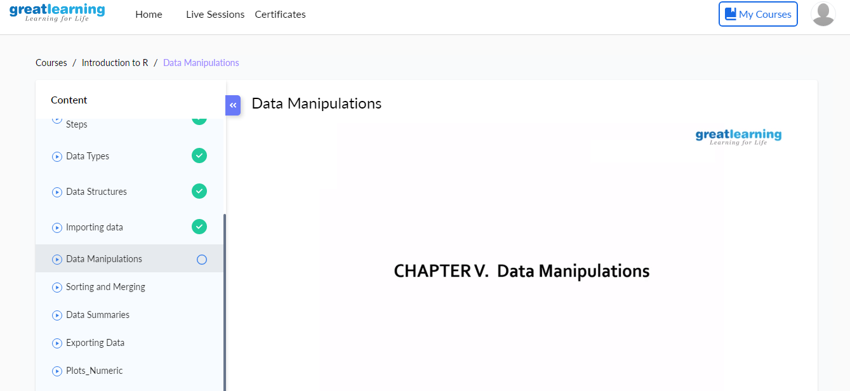

Coding Challenges Details: (Attach the snapshot and briefly write the report for the same)

Coding was given n it was uploaded for github and slack

Coding Challenges Details:

PROGRAM1

# Python program to display the Fibonacci sequence

defrecur_fibo(n):

if n <= 1:

return n

else:

return(recur_fibo(n-1) + recur_fibo(n-2))

nterms = 10

if nterms<= 0:

print("Plese enter a positive integer")

else:

print("Fibonacci sequence:")

for i in range(nterms):

print(recur_fibo(i))